
Enter paragraph text here

CarePort Care Management

External Authentication
JumpPoints
Security Feed

Technical Guide
Table of Contents
External Authentication 1
External Authentication Feature Overview 1
External Authentication Benefits 1
Supported Identity Server Products 1
Decide on the Identity Claim 2
Map the Identity Claim to a User Account 2
Enable External Authentication 3
Client Shortcut for External Authentication Login 3
Impacts to Other Features 3
External Authentication Provider Configuration 4
EA Overview 4
Configure Active Directory Federation Services (ADFS) 5
Configure OpenID Connect 6
Configure SAML 7
Send ACM Metadata to Identity provider (IDP) 8
Receive Metadata from Identity provider (IDP) 9
SAML Azure Configuration Example 9
Initial testing of the External Authentication configuration 12
Configure User Accounts for External Authentication Testing 12
Test the Login Process 13
Troubleshoot External Authentication 13
Migrating Existing Clients to External Authentication 14
External Authentication User Migration Tool 14
JumpPoints (Launching Care Management with a URL) 16
JumpPoint functionality 16
How to use 16
JumpPoint URLs and parameters 17
HTML example for JumpPoint testing 22
Use External Authentication SSO with JumpPoints 23
CarePort Security Feed 24
Security Feed Overview 24
Programmatically Updating Care Management User Accounts 24
Schema File for the Security API Document 24
URL of Data Processing Page 25
Security Feed Processing Rules Request Level Validation 26
Organization Level Validation 26
User Level Validation and User Profile and Organization Association Processing 27
Security API Sample Document 31

External Authentication

External Authentication Feature Overview
Authentication is the process of verifying user credentials for a named user, usually based on a username and password. The External Authentication feature enables an organization to assign Single-Sign-On (SSO) capabilities to a CarePort™ Care Management user base.
It is the responsibility of an organization to maintain an Identity Server to authenticate users in the company domain. External Authentication is only an integration protocol that uses industry standards to communicate between the Care Management login page and the identity server.

External Authentication Benefits
Users in an organization can benefit by using External Authentication in the following ways:
- Users can log on to CarePort™ Care Management using the same credentials used to log on to the organization network.
- Depending on the configuration of the organization Identity Server users may experience fewer prompts to enter credentials to access Care Management.
- An organization has direct control over preventing access for employees who have left the organization. Even when the user account is still enabled in Care Management, an organization can disable the account in the company directory and deny access for the former employee.

Supported Identity Server Products
The External Authentication feature is designed to support two common Identity Server configurations.
- Microsoft© Active Directory Federation Services (ADFS), versions 2.0 and 3.0
- Third-party Identity Servers such as PING Federated that support OAuth2, OpenID Connect, and SAML protocols.
ADFS is designed to work on top of Microsoft© Active Directory. Third-party products are used by organizations with non-Microsoft© directory servers.
NOTE: ADFS 4.0 (2016) explicitly supports OpenID Connect protocol.
For both scenarios, the standard is OAuth2 and the specific profile supported is “Authorization Code Flow”.

Decide on the Identity Claim
Organizations must choose the specific “claim” that will be issued by the Identity Server to uniquely identify a user in the company domain, and consequently in the Care Management application.
There are two common approaches:
- Issue the user’s organization email address as the identifying claim.
- Issue a custom claim that concatenates the user’s organization ID with an organization-specific suffix.

When feasible, configure the user’s organization email address as the identifying claim. Not all organizations issue email addresses to all of their users who have access to Care Management.
Alternately, it is acceptable for an organization to configure a custom claim that uses the users organization ID (for example, “JSmith” or “J4257” along with a suffix unique to the organization. The resulting claim might be “JSmith@MyOrganization.com” or “J4257@MyOrganization.com”.

Map the Identity Claim to a User Account
The Identity Claim selected to uniquely represent a Care Management user must be mapped to a Care Management login name.
Existing clients migrating to External Authentication may require updates to existing login names to match the new Identity Claim. For example, an existing user in Care Management with a login name of “JSmith” must be updated to an identity claim that resembles an email address with an embedded “@”, such as, “JSmith@MyOrganization.com”. The login name does not need to be changed if it already matches the custom claim that will be received from the Identity Server.
New clients anticipating the use of External Authentication should create new users accounts with the correct format. The login name must resemble an email address with an embedded “@” and appropriate suffix that uniquely ties the user account to the client organization.
NOTE: When using an email address as the identifying claim, there is no direct connection in Care Management between the user profile login name and email address, even though the information matches. When a user changes their email address in either of these applications, the change does not affect their ability to login using External Authentication.

Enable External Authentication
You must activate the External Authentication feature at both the organization level and individual user account level. An organization can be enabled for External Authentication
after the External Authentication Provider is configured and individual user profiles are enabled for External Authentication.

Native Users
Organizations configured for External Authentication can still create native users that can login to Care Management directly without using SSO. This is necessary at times for users that support the application and report writers whose usernames cannot contain an embedded “@” symbol.

Multiple Organizations
External Authentication can support users that require access to multiple organizations when all organizations are configured for External Authentication.

Client Shortcut for External Authentication Login
After all configuration, testing, and user migration operations are completed a desktop shortcut (or equivalent) that automatically logs the user into Care Management using the SSO capability of External Authentication can be created.
For the Training and Production environments, the shortcut is constructed as in the following examples for the fictitious ACME customer.
https://training.extendedcare.com/professional/home/EAlogon.aspx?Provider=ACMEConnect
https://www.extendedcare.com/professional/home/EAlogon.aspx?Provider=ACMEConnect

Impacts to Other Features
The use of External Authentication impacts other Care Management features.

Security Feed
The Security Feed supports both native and External Authentication users, but only one form of authentication is supported per organization. A separate URL is provided for each type of authentication in the Training and the Production environments. The only difference in the structure of the submitted data is the user password element is omitted for External Authentication.

Jump Points
Jump Points fully supports External Authentication.

Assessments
The signing functionality of assessments is designed to recognize when External Authentication is activated for an organization. The password box is not enabled in this case and the user must click Sign to initiate the process.

Report Builder
Report Builder does not support External Authentication. Report Designers must use a native account.

External Authentication Provider Configuration
Clients using External Authentication must partner with a Care Management team member to establish the configuration of the External Authentication Provider hosted by the organization.

EA Overview
The configuration settings are entered by the CarePort™ Care Management team member. The following configuration items are exchanged between the organization and Care Management.
Table 1: Configuration Items
Configuration Item | Responsibility | Comment
Client ID | Generated by client | Identifies the client’s application
Client Secret | Generated by client | Not used with ADFS 3.0
Authentication Endpoint URL | Provided by client | First leg of the Authorization Code Flow
Token Request URL | Provided by client | Second leg of Authorization Code Flow
Redirect URL | Provided by Care Management | Always the same per environment
User Name Key | Specified by client | Name of claim in token that identifies the user
Scope | Mutual agreement | Must include “openid” for OpenID Connect
Resource (Relying Party Trust) | Specified by client | For ADFS only

Configure Active Directory Federation Services (ADFS)
It is the client’s responsibility to configure the Identity Server for an OAuth2, OpenID, and SAML exchange with a CarePort™ Care Management for a common ADFS configuration.
The following screenshot is an example of the values for OAuth2 as required by Care Management.
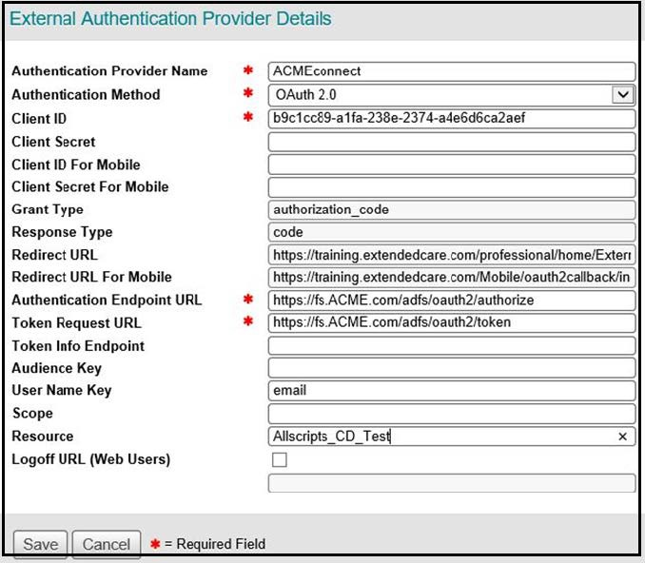
Figure 1: OAuth2 ADFS Provider Example
- For Client ID, enter the client identifier that was provided by the client. The Client Secret value will not be provided for ADFS 3.0.
- Grant Type and Response Type values are fixed by the protocol and cannot be changed.
- The Redirect URL field values are predetermined and must be provided to the client before generating the Client ID and Client Secret values.

- The Authentication Endpoint URL and Token Request URL fields are displayed in the example with realistic values for a client’s ADFS server, but are substituted with the fictitious “ACME” company identifier.
- User Name Key is specified as email in this example.
- Resource (Relying Party Trust) is only used for ADFS. The client must provide this value after configuring the ADFS server.
- Assume that all configured values are case-sensitive, as a precaution to avoid problems during testing.

Configure OpenID Connect
Configure the values for OpenID Connect. The following screenshot demonstrates the values that are completed for OpenID Connect as required by Care Management.
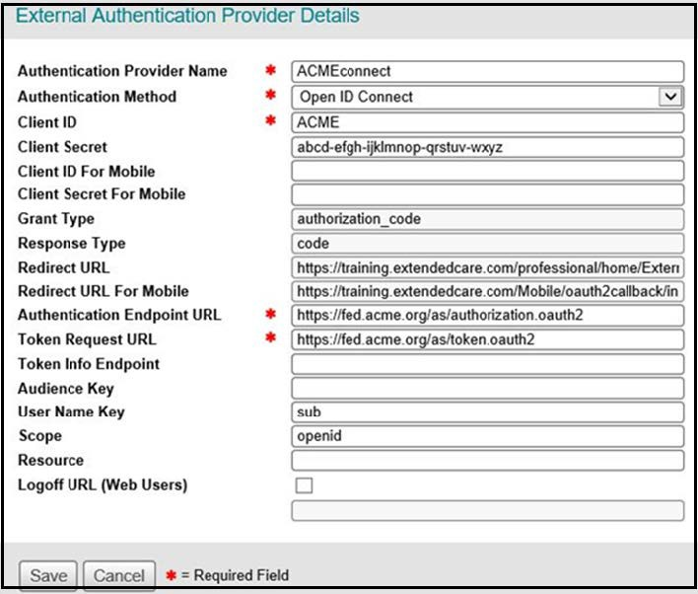
Figure 2: OpenID Connect Provider Example

- By convention for Authentication Provider Name, enter the client’s abbreviation followed by “connect”. For example, ACMEconnect was used as the fictitious identifier. For OpenID, the value for Authentication Method must be entered as Open ID Connect.
- For Client ID and Client Secret, enter the client identifier and secret that were provided by the client.
- Grant Type and Response Type values are fixed by the protocol and cannot be changed. The Redirect URL fields are predetermined and must be provided to the client before generating the Client ID and Client Secret values.
- The Customer Authentication Endpoint URL and Token Request URL fields are demonstrated with realistic values for an OpenID server using PING Federated by substituted with the fictitious “ACME” company identifier.
- In this example, User Name Key was specified as sub, which is an abbreviation for “subject”. Scope is always specified as OpenID. At the client’s request other scopes can be added (separated by spaces) in the field.
- Assume all configured values are case-sensitive, as a precaution to avoid problems during testing.

Configure SAML
Configure the values for SAML. Below are basic steps that need to be carried out by clients to configure External Authentication for SAML in CarePort Care Management.

SL No | Steps | Description
1 | Send ACM Metadata to Identity provider (IDP) | Metadata is xml file, which contain information about AssertionConsumerService and certificate (TrainingMetadata.xml)
2 | Receive Metadata from Identity provider (IDP) | IDP Metadata is xml file and which contains information about IDP
3 | Configure External authentication for SAML | Upload IDP metadata file in ACM
4 | Assign External Authentication for Org/User | Assign external authentication provider created on step 3 to organizations and user

Send ACM Metadata to Identity provider (IDP)
Metadata is an xml file, which contain information about AssertionConsumerService and certificate of ACM(TrainingMetadata.xml). IDP will upload this metadata file while creating application at their end.

The following is the example metadata file:

<md:EntityDescriptor entityID="https://training.extendedcare.com/professional/home/ExternalAuthentication/AssertionConsumerCallback.aspx" ID="_696bc0a6-d53f-49a0-9f2e-8b8273ede003" xmlns:md="urn:oasis:names:tc:SAML:2.0:metadata">

<md:SPSSODescriptor ID="_5b6853d6-dcd0-4c1d-a1ea-4abe2e58841c" protocolSupportEnumeration="urn:oasis:names:tc:SAML:2.0:protocol" AuthnRequestsSigned="true" WantAssertionsSigned="true">

<md:KeyDescriptor use="signing">
<KeyInfo xmlns="http://www.w3.org/2000/09/xmldsig#">
<X509Data>
<X509Certificate>……X509Certificate>
</X509Data>
</KeyInfo>
</md:KeyDescriptor>
<md:KeyDescriptor use="encryption">
<KeyInfo xmlns="http://www.w3.org/2000/09/xmldsig#">
<X509Data>
<X509Certificate>…..X509Certificate>
</X509Data>
</KeyInfo>
</md:KeyDescriptor>

<md:AssertionConsumerService Binding="urn:oasis:names:tc:SAML:2.0:bindings:HTTP-POST" Location="https://training.extendedcare.com/professional/home/ExternalAuthentication/AssertionConsumerCallback.aspx?binding=urn%3aoasis%3anames%3atc%3aSAML%3a2.0%3abindings%3aHTTP-POST" index="0" isDefault="true" />

</md:SPSSODescriptor>

</md:EntityDescriptor>

Receive Metadata from Identity provider (IDP)
IDP Metadata is xml file and which contains information about IDP. Once IDP creates the Application, they will have sent us the IDP metafile. Metadata file will contain SingleSignOnService url and certificate.

The following is the example metadata file:

<?xml version="1.0" encoding="UTF-8"?><md:EntityDescriptor xmlns:md="urn:oasis:names:tc:SAML:2.0:metadata" entityID="https://portal.sso.us-east-1.amazonaws.com/saml/assertion/NzkxMjI2MDMxMzM1X2lucy1mODZhMTc5YzJkYTU3ZTdh">

<md:IDPSSODescriptor WantAuthnRequestsSigned="true" protocolSupportEnumeration="urn:oasis:names:tc:SAML:2.0:protocol">

<md:KeyDescriptor use="signing">
<ds:KeyInfo xmlns:ds="http://www.w3.org/2000/09/xmldsig#">
<ds:X509Data>
<ds:X509Certificate>…..</ds:X509Certificate>
</ds:X509Data>
</ds:KeyInfo>
</md:KeyDescriptor>

<md:SingleSignOnService Binding="urn:oasis:names:tc:SAML:2.0:bindings:HTTP-POST" Location="https://portal.sso.us-east-1.amazonaws.com/saml/assertion/NzkxMjI2MDMxMzM1X2lucy1mODZhMTc5YzJkYTU3ZTdh"/>

</md:IDPSSODescriptor>

</md:EntityDescriptor>

SAML Azure Configuration Example
- Enable a single organization for External Authentication for testing purposes.
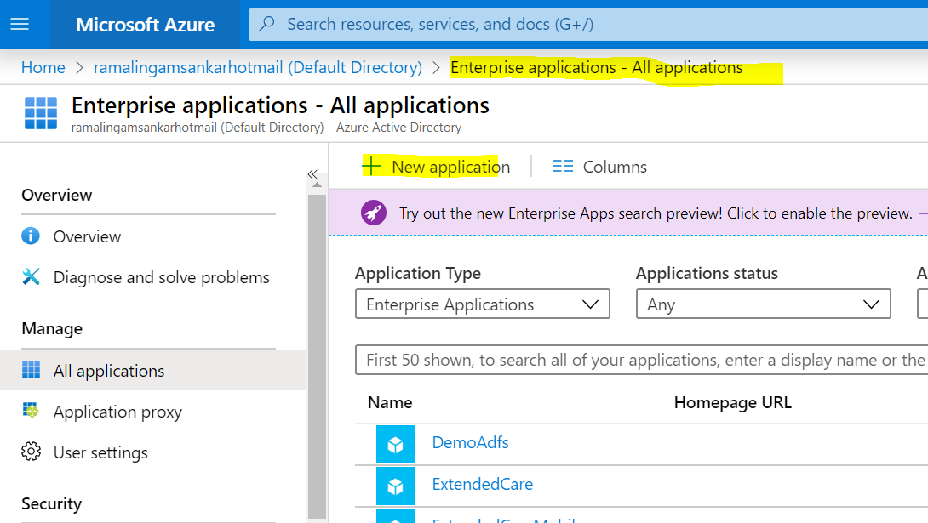

- Click on Non-gallery application
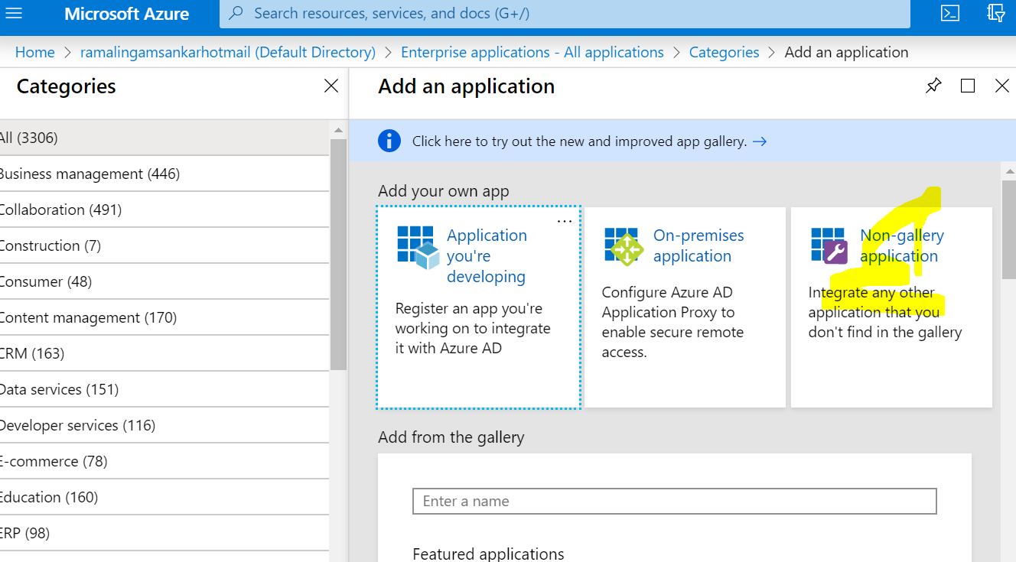
- Fill in the new name
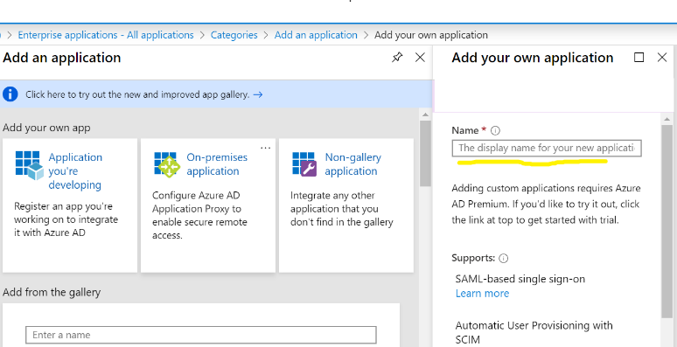

- Upload the metadata file from CarePort
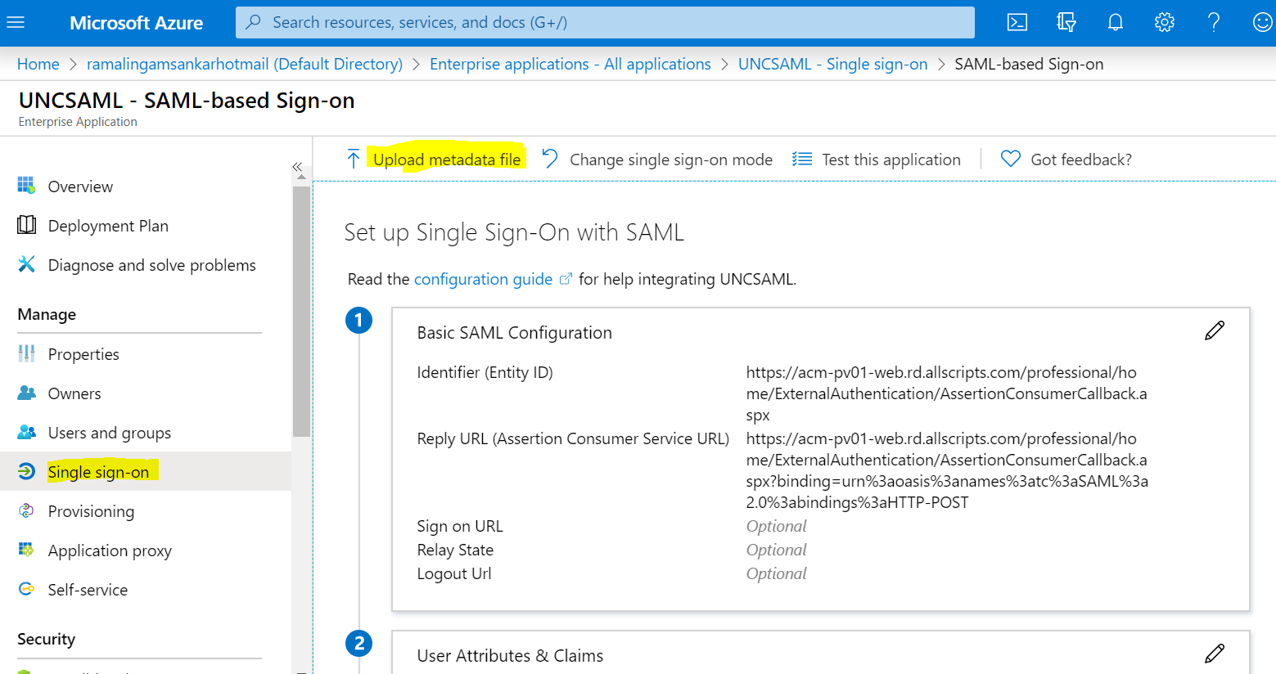

- Update the attribute and download the metadata file from IDP
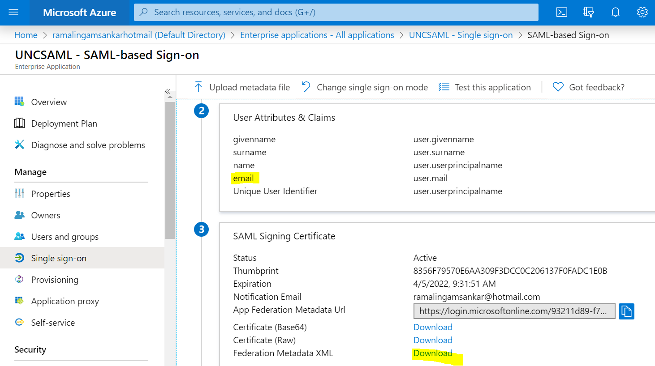

- Update the signing option and algorithm.
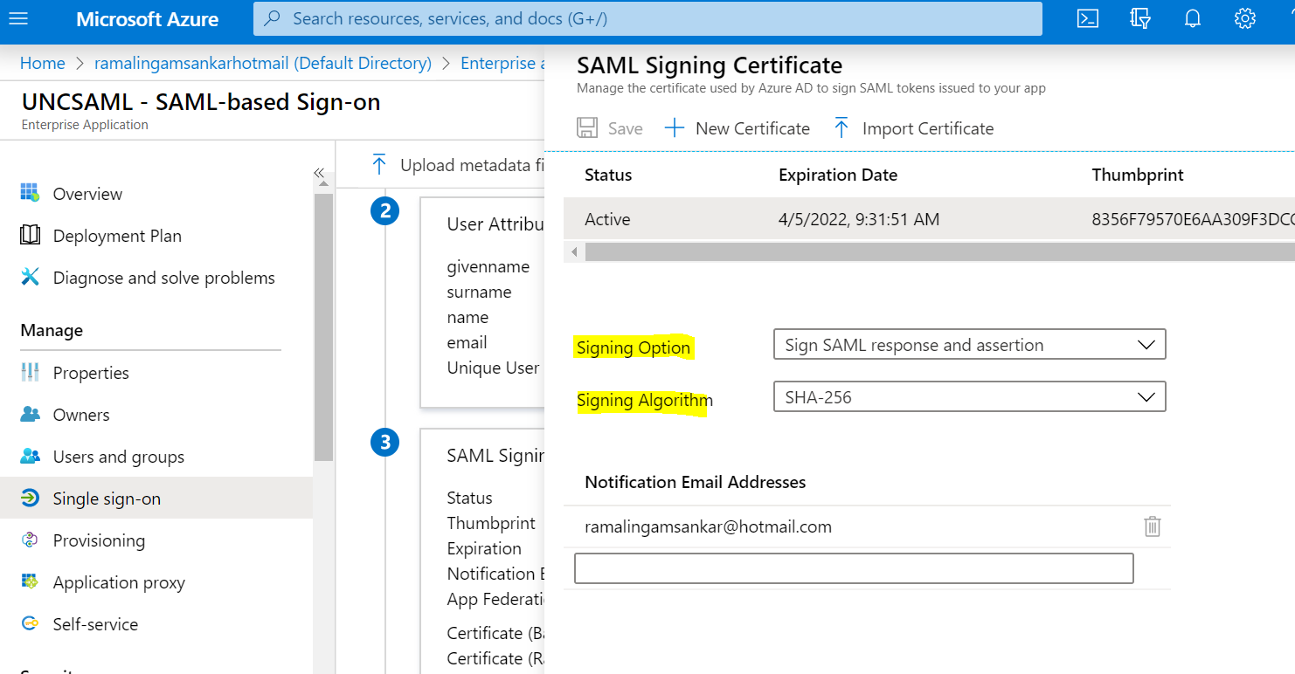

- Choose either "Sign SAML response" or "Sign SAML response and assertion"
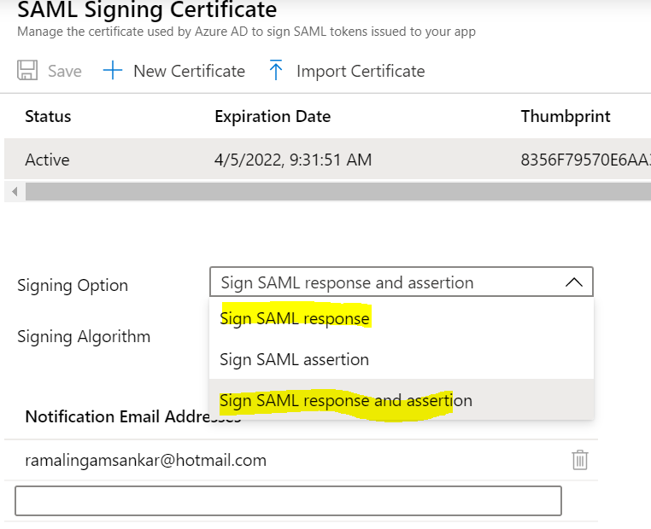

- Send the Downloaded metadata file to CarePort.

Initial testing of the External Authentication configuration
External Authentication must be configured and tested in the Training environment prior to attempting External Authentication in Production. Review and complete all steps to test and confirm a successful login with External Authentication.
Choose an organization to be configured for External Authentication
Health systems with multiple organizations should work with a CarePort™ team member to select on organization to be used for testing.
It may be necessary to test in more than one organization if users in the health system will need multi-org access.
Once the test organization(s) have been selected configure the organization(s) for External Authentication.

Configure User Accounts for External Authentication Testing
Only user accounts with a login (username) that resembles an email address (for example “JSmith@testing.com or “J4285@testing.com” can be used for testing External Authentication. These login names must match the identifying claim that will be returned by your organization’s Identity Server. It might be necessary for you to create a new user account with the correct login name, which will only be used for testing purposes.
Complete the following steps:
- Log in to the organization that owns the testing user profile.
- Navigate to Configure > Security > Users.
- NOTE: Only users with the security role of Security Administrator have access to the Security menu items.
- Locate the user account to be used for testing.
- Select the check box next to Enable External Authentication from the Account Security section of the user profile. The name of the authentication provider is displayed to the right as shown below:

Figure 3: Profile Authentication Provider
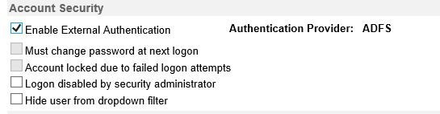
NOTE: When the user has a default organization that is different from the owning organization, the default organization must also be configured for External Authentication and the same authentication provider used.

Test the Login Process
The login process is tested by a client’s team member. Test the login process by going to the main login screen. Instead of entering the user name and password, enter the name of the External Authentication Provider configured by the client.
When the configuration is correct a prompt to login to the company domain by the organizations Identity Server displays. Upon successful login, you are redirected to the default organization.

Troubleshoot External Authentication
While testing the External Authentication login process, Errors may occur on the Identity Server or on the Care Management login page.
Errors from the Identity Server imply a configuration problem on the organization’s server or a mismatch of shared configuration values. As a precaution, case-sensitivity must be checked on all shared settings.
Errors from the Care Management web server display the message, Invalid User Name or Account Locked. Please try again. If you need assistance, contact a Security Administrator at your organization.
To determine the root cause of login errors, the database logging feature for External Authentication must be activated.
Activate database logging
CarePort™ team members can activate database logging. Currently, only one client at a time can have database logging enabled.
Database logging is activated by assigning appropriate values to two CarePort configuration settings.
Table 2: Database Logging Values
Setting Name | Setting Value | Comment
LogEAWorkflow | 1 | Set to 1 to activate logging
EAProvider | ACMEconnect | The name of the EA Provider
Two database tables located in the primary database capture External Authentication information.

Table 3: Database Tables
Table | Comment
EALoginWorkFlowAudit | Records the occurrence of an EA Login Attempt
EALoginWorkFlowAuditDetail | Records details of the token exchange and login failure codes
The parent table records the name of the provider (for example, ACMEconnect), the IP address of the client, the web server that handled the request, and the timestamp of the
request. The detail table (associated by the same ID) records the details of the token exchange, and any login failure code issued by the Care Management login process. MessageType = 1 represents a normal message, and MessageType = 2 represents an Error message.

Migrating Existing Clients to External Authentication
The first requirement for migrating user account to use External Authentication is that the login name is in the form of an email address (for example, “JSmith@MyCompany.com” or “J4256@MyCompany.com”) Usernames like “JSmith” or “J4256”, which are acceptable for native authentication, will not work for External Authentication.
The second requirement for migrating user accounts to use External Authentication is that each account is explicitly designated in the User Profile to require login with External Authentication. After this step is performed the user can no longer login with a username and password using native authentication.

External Authentication User Migration Tool
The tool is useful only as a one-time migration for existing clients, where all user logins are in the legacy form (for example, without “@MyCompany.com” as a suffix).
This tool can only be run by a CarePort™ team member. This tool cannot be used for clients who have already started naming their accounts with company-specific suffixes in anticipation of using External Authentication, or for any clients already following the required login naming convention for External Authentication as it does not migrate users that do not require a login name change.
The tool is intended to be used prior to activating an organization for External Authentication, such that when the organization is activated, the migrated user accounts are automatically configured at the user level for External Authentication. If this order is not followed, all user accounts must be manually marked for external Authentication in the user profile of each account.
The migration tool does not enable a user for External Authentication. It marks the user profile as being “Migrated for EA”, so that when the user’s owning organization is activated for External Authentication, the user account is also activated.
When many users are migrated to External Authentication, and the organization is returned to native mode for any reason, then the migration tool cannot be used to re- enable the users for External Authentication since it only works one time during the initial login name update.
The following test scenario can determine if it would be feasible for an organization to use the tool:
- Enable a single organization for External Authentication for testing purposes.
- Enable one or more user accounts manually in User Profile for testing only.
- After a successful test, prepare a spreadsheet of user accounts to be migrated. This spreadsheet would exclude the few users that were already setup for testing.
- Disable the organization for External Authentication. This will reset the test users back to native mode.
- Upload the spreadsheet through the User Profile Migration tool.
- Re-enable the organization for External Authentication. All migrated users will be configured for External Authentication. The few test users must be manually re- enabled for External Authentication.
- When using the tool for a health system, all users who have an owning organization belonging to the health system will be marked for migration. The CarePort Administrator must enable External for all organizations in the health system and consequently enable the users marked for migration.

JumpPoints (Launching Care Management with a URL)

JumpPoint functionality
A JumpPoint is a special URL that enables your organization's users to launch their favorite pages directly from CarePort™ Care Management. Also, users can access their favorite pages without directly logging on to CarePort™ Care Management by using an external authentication method and if Single Sign-On (SSO) is enabled for your organization.

How to use
JumpPoints are typically set up in other third-party applications, such as an electronic health record (EHR) application. These applications typically allow your organization to set up a custom button that is similar to a bookmark in a Web browser. When you click this button, a Web browser opens and takes you to the specified JumpPoint page in CarePort Care Management, as demonstrated in the following figure.
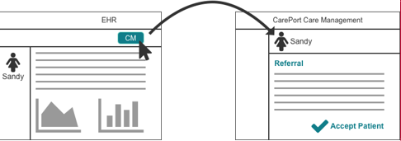

JumpPoint parameters
JumpPoints accept a variety of parameters, depending on the specific JumpPoint destination page that was specified. Accepted parameters can include the following:
- A username, password, and organization code to log on to the CarePort® system
- A JumpPoint page identifier
- The patient's last name
- A medical record number (MRN)
- An account number
Based on the authentication values that are received by CarePort™ Care Management, users are taken to one of the following pages:
- The page that is specified in the request
- The preferred start page
- The CareInMotion™ logon page (if the user cannot be authenticated)

Note: To configure your organization for JumpPoint functionality, contact CarePort™ Care Management Support or Services.

JumpPoint URLs and parameters
Use the following URLs and parameters when your organization is configured for JumpPoints.

JumpPoint URLs
CarePort™ Care Management Production and Training sites support the use of the JumpPoint mechanism. When users access the application on a given site, the JumpPoint mechanism
redirects them to a page on the same site. For example, if you access the JumpPoint mechanism on the CarePort™ Care Management Training site, a page from CarePort™ Care Management Training is displayed, not a page from the CarePort™ Care Management Production site.

Supported URLs
Use the following URLs to access the JumpPoint mechanism:
Production site

https://www.extendedcare.com/professional/WebServices/xmlb2b/JumpPoints.aspx
Training site

https://training.extendedcare.com/professional/WebServices/xmlb2b/JumpPoints.aspx

System requirements
To use JumpPoints for external authentication, your application must have the following system requirements:
- An SSL-encrypted connection (HTTPS: protocol)
- Either the GET or the HTML forms POST method
- Parameters to the jump point processor passed in form fields, as described in the JumpPoint parameters table

JumpPoint parameter table
The JumpPoint mechanism requires the caller to pass certain data elements. These data elements are passed as parameters with the JumpPoint URL.
The following table lists the available JumpPoint parameters, which includes the form field names, descriptions of the field, and whether the field data is a requirement for external authentication.

Form field name | Description | Required?
JumpPointID | The numeric identifier of the jump point to be accessed | Yes
UserName | The logon name of the user to be authenticated | Yes - if not using Single Sign-On (SSO)
Password | The password of the user to be authenticated | Yes -if not using SSO
ProviderData | The external authentication provider name | No - only if SSO is enabled
UserOrgCode | The assigned code from  CarePort that identifies the organization that the user is accessing | Yes - only when JumpPoints are enabled for your organization by CarePort Care Management Support or Services
SiteCode | The organization site code | No - used for organization that also have defined facilities
MRN | The medical record number (MRN) of the patient | No
HospitalAdmissionID | The patient's account number | No
ReferralLinkID | The CarePort®-generated  identifier that is associated with the referral | No
ReferralNumber | The CarePort®-generated  identifier of the existing referral | No
PatientLastName | The last name of the patient | No
DateOfBirth | The patient's date of birth | No
SSN | The patient's Social Security Number (SSN) | No
PayorContactFirstName | The first name of the payor contact | No
PayorContactLastName | The last name of the payor contact | No
PayorContactPhoneNumber | The phone number of the payor contact | No

Form field name | Description | Required?
PayorContactFaxNumber | The fax number of the payor contact | No
PayorPlanID | The unique identifier for the payor plan | No
FileAttachmentName | The name of the file attachment | No
ReviewSenderUserName | The name of the user who sent the review | No
ReviewDate | The date that the review was sent | No
person | An alternate to HospitalAdmissionID which equates to a patient’s account number. This was added for Cerner clients unable to send HospitalAdmisisonID | No

JumpPoint Characteristics
The following table details the characteristics of each JumpPoint that is supported by CarePort Care Management. Information includes:
- The JumpPoint numerical identifier
- The JumpPoint destination page
- The parameters that can be passed to the JumpPoint (required or optional)

JumpPoint ID | Destination page | Required data | Optional data
1 | Home Page
5 | Patient Details | - Patient Last Name  - MRN
8 | Referral Creation Tool | Account #
13 | Admit Express |  | - Patient Last Name  - MRN and/or  Account #
14 | Patients Worklist |  | Patient Last Name or  MRN
15 | Admissions Worklist |  | - Patient Last Name  - MRN and/or  Account #
23 | Incoming Professional |  | - Patient Last Name  - SSN

JumpPoint ID | Destination page | Required data | Optional data
 | Referrals/Inquiries  view |  | - DOB  - Referral ID
25 | Admission Details | Account #
26 | Discharge | Account #
27 | Referral Activity Worklist |  | - Referral ID  - Referral Link ID  - Account # or MRN
29 | Admission Face Sheet | Account #
30 | Patient Face Sheet | Patient Last Name or  MRN
31 | Forms & Attachments | Account #
32 | Review Referral | Review Referral
33 | Send  Correspondence |  | - Payor Contact First Name  - Payor Contact Last Name  - Payor Contact Phone Number  - Payor Contact Fax Number  - Payor Plan ID  - File Attachment Name  - Review Date
34 | Review Fax Status Report |  | - Account #  - Review Sender User Name
28 | "Intelligent" JumpPoint |  | - Referral ID  - Referral Link ID  - Account # or MRN

"Intelligent" JumpPoints
The "Intelligent" JumpPoint mechanism dynamically determines the user's destination page. The destination page is based upon the current status of the patient, the admission, or the referral
information that is provided in the JumpPoint request. The following table describes the data provided and the subsequent page that is displayed.

Data provided | Page displayed
- MRN  - HospitalAdmissionID  - ReferralLinkID | If the referral is associated with the ReferralLinkID, processing is the same as if the referral number was provided instead of the  referral link ID.  If no referral is associated with the referral link ID, the Admissions Worklist is displayed and filtered for the admission.
- MRN  - HospitalAdmissionID  - ReferralNumber | If the referral was previously closed, the Admissions Worklist is displayed and filtered for the admission.  If the referral was previously posted, the Referral Activity page is displayed and filtered for the referral number.  If the referral is not yet posted, the Referrals page is displayed and filtered for the referral number.
- MRN  - HospitalAdmissionID | The Admissions Worklist is displayed and filtered for the admission.
MRN | The Patients Worklist is displayed and filtered for the MRN.

HTML example for JumpPoint testing
The following HTML page enables you to test a JumpPoint from a Web page. Use this test page to launch into your Training or Production organization. The JumpPoint test page file is named ClientJumpPointsTestPage2.html and is available with this documentation.
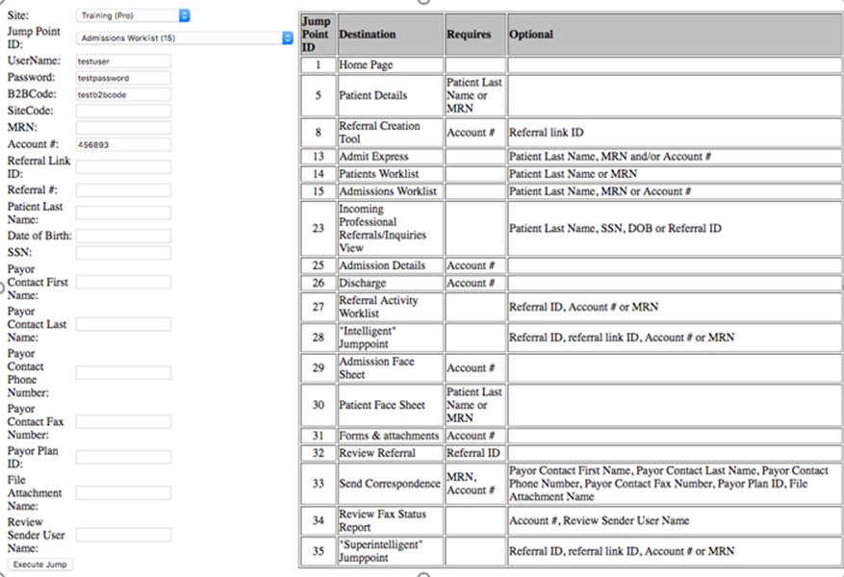
To test a JumpPoint page, complete the following steps:
- For Site, select a training or production organization site.
- For Jump Point ID, select the JumpPoint identifier for the destination page.
- Enter in any required data for that JumpPoint.
- Click Execute Jump.

Example of a JumpPoints URL

Use External Authentication SSO with JumpPoints
If CarePort Care Management is enabled with Single Sign-On (SSO), specify the ProviderData parameter before you launch the JumpPoint URL.
The ProviderData parameter is created when SSO is enabled for both CarePort Care Management and your organization. The UserName and Password parameters are not passed to CarePort Care Management when you use SSO.
To learn more about how to enable SSO for your organization, contact any of the following:
- CarePort Care Management Customer Support
- Your CarePort Care Management Sales Associate
- Your CarePort Care Management Client Advocate Associate

SSO JumpPoint URLs
Use the following URLs to access the JumpPoint mechanism with SSO:
Production site

https://www.extendedcare.com/professional/WebServices/xmlb2b/EAJumpPoints.aspx
Training site

https://training.extendedcare.com/professional/WebServices/xmlb2b/EAJumpPoints.aspx

Example of a JumpPoints URL using EA and SSO

CarePort Security Feed

Security Feed Overview
The CarePort Care Management Security Feed provides third party applications with the ability to load user authentication and authorization data into CarePort system over encrypted web connections. This document will provide the information necessary to begin interfacing with CarePort Care Management using the Security Feed.

Programmatically Updating Care Management User Accounts
CarePort Care Management supports an XML-based interface, known as the Security API, which allows clients to programmatically manage their Care Management user accounts. The interface is implemented as an HTTP POST over an SSL-encrypted link, and implements the following functionality:
- Add or remove a user for a specific location
- Remove a user permanently
- Update a user’s logon name, password, or other user attributes (phone number, etc.)
- Add or remove a user’s roles on a per-location basis
- Add or remove a user’s membership in Security Groups on a per-location basis

Schema File for the Security API Document
CarePort maintains the schema files for the XML documents used to communicate with the Security API. Browsing these documents is the quickest way to familiarize yourself with the functionality provided by the Security API.
On the production servers at http://www.extendedcare.com/professional/WebServices/Schemas/SecurityData.xsd
On the training services at http://training.extendedcare.com/professional/WebServices/Schemas/SecurityData.xsd

Refer to the Security API Sample Document XML at the end of this document for a sample that meets the requirements of the XSD.

URL of Data Processing Page
Once the external application has created the user data XML document, it is sent to CarePort for processing by accessing a web page on CarePort servers. The transmission of the data is characterized by the following.
- The connection is SSL encrypted for security (i.e., the HTTPS: protocol is used)
- The XML document is sent using the HTTP POST method
- The processing request is subject to CarePort standard security features including:
- Under Construction checks
- Logins being locked or disabled
- Organization access rights
In addition to the username and password authorization credentials contained in the XML document, an IP address validation is performed to ensure that only IP addresses that are explicitly configured in the Care Management application are allowed to submit data through the Security Feed.
CarePort supports 2 different types of user management: Native and Externally Authenticated. An organization that chooses to use a Security Feed for user management must choose one or the other. Different user authentication types cannot be mixed in the same feed.

To load data into CarePort production system for native Care Management users, post to https://www.extendedcare.com/professional/webservices/xmlb2b/CanopySecurityFeed.aspx
To load data into CarePort production system for Externally Authenticated Users, post to https://www.extendedcare.com/professional/webservices/xmlb2b/ExternalAuthSecurityFeed.aspx
To load data into CarePort training system for native Care Management users, post to https://training.extendedcare.com/professional/WebServices/xmlb2b/CanopySecurityFeed.aspx
To load data into CarePort training system for Externally Authenticated Users, post to https://training.extendedcare.com/professional/webservices/xmlb2b/ExternalAuthSecurityFeed.aspx

Security Feed Processing Rules Request Level Validation
The following conditions must be met when a submitting an XML request document to a Security Feed web page:
- The Care Management web site is not under construction for a deployment event
- The XML must be valid XML
- The XML must satisfy the rules defined in the SecurityData.xsd schema file
- The IP address of the requesting application must be configured with CarePort to permit access
If any of these conditions are not satisfied, the Response will contain an error message indicating the cause of failure and all further processing is abandoned.

Organization Level Validation
Each request document can contain one or more Security nodes (refer to the sample XML in the Appendix), and each Security node represents processing requests for one or more users within an Organization. The following Organization level validation rules are applied:
- The Organization Code specified in the Organization element of the Logon node of the Request must map to a valid Care Management organization.
- The user specified in the Logon element of the Request must be a valid logon attempt for the specified Organization. This includes password validation, account validation (user account is not locked out, disabled, or deleted) and the user is associated to the organization. The Logon user must be a Care Management native user, even for the External Authentication feed.
- The user specified in the Logon element of the Request must be a Security Administrator for the Organization.
- If the request is being processed by the Security Feed URL for External Authentication, then the Organization specified in the Logon node must be configured for External Authentication.
- If the request is being processed by the Security Feed URL for native authentication (“CanopySecurityFeed”), then the Organization specified in the Logon node must be configured for native authentication.
If any of the above conditions are not satisfied, the Response will contain an error message indicating the cause of failure and all processing for the current Security node is abandoned. Processing will continue with the next Security node (Organization).

User Level Validation and User Profile and Organization Association Processing
Each Security node contains a “Users” node with one or more User elements. The following operations are valid for a User (refer to the sample XML in the Appendix):
- OpCode = “ADD”
- OpCode = “UPDATE”
- OpCode = “DELETE”
- OpCode = “TRANSFER”

ADD
The ADD operation has the dual purpose of adding a new user for the first time, and associating an existing user to a new organization. It can also be used to update a user.
- If the username specified does not exist, a new user profile is created and the user is associated to the organization specified in the Logon element. This becomes the User’s “Owning Organization”. The user’s roles and security groups are processed as described below.
- If the username already exists and this is the user’s owning organization, then a password update (for native feed only) and user profile update are performed. The user’s roles and security groups are processed as described below.
- If the username already exists, but this is not the user’s owning organization, then a check is made to ensure that the Logon user has Security Admin rights to the owning organization for this user. If this condition is met, the user’s password is updated (Native Feed only), otherwise it is not updated. The user is then associated to the Organization (as a non-owned user), the user profile is updated, and roles and security groups are processed as described below.
- For users being added through the External Authentication Feed, the username must be in the form of an Email address (e.g. johnsmith@myorganization.com).
- For users being added through the Native Feed, the password provided must meet the password rules defined for the organization (upper case, number, mixed case, length, etc)
- Organizations that use External Authentication can choose to manually configure a user as a Native user, through the Care Management application. When this is done, the External Authentication Security Feed cannot be used to manipulate security information for these users. If this is attempted, an error message will indicate that the authentication provider for the user does not match the authentication provider for the organization. Processing continues with the next user.
Note that the successful response when processing the ADD operation for a user does not indicate if the user was newly added or already existed but was associated to a new organization or only the user profile was updated.

UPDATE
The UPDATE operation is restricted to only performing updates on an existing user profile and organization association. A user will never be created or newly associated to an organization through the Update operation.
- If the username specified in the User element does not exist, or if the user is not associated to the current Organization, then a warning message is reported in the Response and processing continues with the next user operation under the “Users” node.
- For the External Authentication Security Feed, the user name must be in the form of an email address, as described above for ADD. Also, manually configured Native users cannot be updated through this feed, as described above for ADD.
- If the Logon organization matches the user’s owning organization, then the password is updated (Native Feed only and subject to password rules defined for the organization) and the user profile is updated.
- The user’s roles and security groups are processed as described below.

DELETE
The DELETE operation is limited in scope to prevent accidental deletion of a large number of user associations and related data in a single operation.
- If the username specified does not exist, or the user is not associated with the current Organization, then a warning message is reported in the Response and processing continues with the next user operation. As with other operations, the Logon user must be a Security Administrator in the organization specified for the delete operation.
- If the Delete request is for a user’s association to an organization other than the user’s “Owning Organization”, then the association is deleted. The user profile remains intact and the user’s association to other organizations remain.
- If the Delete request is for a user’s association to their “Owning Organization”, then a check is made to see if the user is associated to other organizations. If there are other associations, a TRANSFER operation (see below) is executed to transfer the user ownership to another org. The new owning org is randomly chosen from the available list of organizations that the user is already associated to. The Delete operation is then carried out, as described above for deleting a user’s association to a non-owning organization. If the Owning Organization is the last organization that the user is associated with, then the Delete request is honored and the user profile is permanently deleted.
Note that the successful response when processing the DELETE operation for a user does not indicate if the user was permanently deleted, or only dis-associated from the current organization.

TRANSFER
The TRANSFER operation is not commonly used but can be specified to change a user’s association to his “Owning Organization” without deleting the user (see the Delete discussion above). To use this feature, specify a “TransferToOrg” that is different from the user’s current owning organization.
- The user must already be associated to this organization as no new associations are created by this operation.
- If the TransferToOrg is the same as the user’s owning organization, no changes occur. If the organization specified does not exist, the user does not exist, or the user is not currently associated to that organization, an error response is recorded. The Logon user must also have Security Administrator rights in both the current owning organization for the user and the specified transfer organization. Finally, the External Authentication Provider (if any) for the user must be the same as the External Authentication Provider assigned to the TransferTo org (if any).
- If all error checks succeed, the user’s owning organization is changed to be the TransferToOrg.
- A future Delete operation can now be used to remove the user’s association to their previous Owning Organization, without actually deleting the user.

User-Level Role Processing
Roles can be assigned to or removed from a user at the individual level. Refer to the Security Groups Processing section below for managing security with Security Groups.
- The list of roles available to your organization can be obtained from CarePort Implementation / Support.
- The role names must be spelled exactly in the Request document, but they are not case-sensitive.
- Roles can be modified through the ADD or UPDATE operations for a user. Each Role (listed under a Roles Node) can use OpCode = “ADD” or OpCode = “DELETE”. If a Role is added that already exists for that user, the Response will still report Success. If a Role is deleted that does not exist for that user, the Response will still report Success. If a Role (Name) is specified that does not exist for the current organization, an error message is written to the Response but Role processing continues normally for that user.
- The ClearExisting attribute can be used separately or in combination with ADD and DELETE operations for roles. If ClearExisting is “true” (or “1”), then all currently assigned roles are removed for the user. If ClearExisting is specified as “true” along with one or more ADD and DELETE operations for individual roles, then the removal of all roles is processed first and then individual ADD operations are processed, and finally individual DELETE operations are processed.
- If the resulting role set after accumulating all operations, matches the user’s existing roleset, then no update takes place.

Security Group Level Processing
Users can be added to the membership of one or more security groups or removed from these memberships. Security Groups are created and managed by the Security Admin for an Organization. The security group names must be spelled exactly in the Request document, but they are not case- sensitive.
- Group membership can be modified through ADD or UPDATE operations for a user. Each SecurityGroup (listed under a SecurityGroups Node) can use OpCode = “ADD” or OpCode = “DELETE”. If a user is added to a security group that he already belongs to, the Response will still report Success. If a user is removed from a Security Group that he does not belong to, the Response will still report Success. If a Security Group (Name) is specified that does not exist for the Organization, an error message is written to the Response but Security Group processing continues normally for that user.
- The ClearExisting attribute works in the same way with Security Groups as it does for Roles as described above.

Security API Sample Document
<?xml version="1.0" encoding="utf-8"?>
<SecurityRequests
xmlns="http://www.extendedcare.com/XMLSchema">
<Security>
<Logon>
<UserName>AdminUser</UserName>
<Password>AdminPassword</Password>
<Organization>Org001</Organization>
</Logon>
<Users>
<User OpCode="ADD" MustChangePassword="false" AccountLocked="false" AccountDisabled="false">
<UserName>user001</UserName>
<Password>z4UBvdIkxLnpXTtn</Password>
<FirstName>Lisa</FirstName>
<MiddleName>M</MiddleName>
<LastName>Jones</LastName>
<DisplayName>Jones,Lisa M</DisplayName>
<Department>Information Systems</Department>
<Position>Dir, Apps &amp; Customer Service</Position>
<Email>LMJones@abc.com</Email>
<PhoneNumber>
<Number>7465558566</Number>
</PhoneNumber>
<Fax>
<PhoneNumber>
<Number>7462119850</Number>
</PhoneNumber>
</Fax>
<Roles ClearExisting="false">
<Role OpCode="ADD">
<Name>Security Administrator</Name>
</Role>
<Role OpCode=”ADD”>
<Name>Organization Administrator</Name>
</Role>
</Roles>
<SecurityGroups ClearExisting=”false”>
<SecurityGroup OpCode=”ADD”>
<Name>Discharge Planners</Name>
</SecurityGroup>
<SecurityGroup OpCode=”DELETE”>
<Name>Care Coordinators</Name>
</SecurityGroup>
</SecurityGroups>
</User>
<User OpCode="UPDATE" MustChangePassword="true" >
<UserName>user002</UserName>
<Password>TempPassword#1</Password>
<FirstName>Christy</FirstName>
<MiddleName>L</MiddleName>
<LastName>Jackson</LastName>
<DisplayName>Jackson,Christy L</DisplayName>
<Department>East - South Central</Department>
<Position>Region Dir, Sales and Mktg</Position>
<Email>CLJackson@abc.com</Email>
<PhoneNumber>
<Number>8875559823</Number>
</PhoneNumber>
<Roles ClearExisting="false">
<Role OpCode="ADD">
<Name>Data Entry Personnel</Name>
</Role>
<Role OpCode=”DELETE”>

<Name>Discharge Planner</Name>
</Role>
</Roles>
</User>
<User OpCode="DELETE">
<UserName>user003</UserName>
</User>
</Users>
</Security>
<Security>
<Logon>
<UserName>AdminUser</UserName>
<Password>AdminPassword</Password>
<Organization>Org999</Organization>
</Logon>
<Users>
<!—- Add, update, delete users for another organization --➔
</Users></Security></SecurityRequests>

Note: The <Password> element under <User> is ignored for External Authentication security feed and can be omitted. The “MustChangePassword” and “AccountLocked” attributes of the <User> element are ignored for External Authentication security feed and can be omitted.

